Lab 2

Part I – Coding “Fish Creek Animal Hospital”

Magda Patel is a veterinarian and owner of the Fish Creek Hospital. Her customers are local pet owners who range from children to senior citizens. Magda would like a website to provide information to her current and potential customers. She has requested a home page, a services page, a page for advice from a veterinarian, and a contact page. A site map for this website is as follows:

Home page

Services
Contact
Ask the Vet

A wire frame sketch of the page layout for the website is as follows:

Site Logo

Navigation

Content

Footer

There are three tasks in this case study:

- Create a folder for the Fish Creek website.

- Create the home page: index.html
  - A template HTML5 page is up on Brightspace. You should use this as a starting point.
  - Open this file using a text editor (Notepad++, Atom…) and save this page as index.html in the Fish Creek folder.
  - Using the tags you have learned so far, code this page so that it looks like the screen shot below in the Fish Creek folder.

- Create the Services page: services.html. Code this page so that it looks like the screen shot below and save it
index.html should look like:

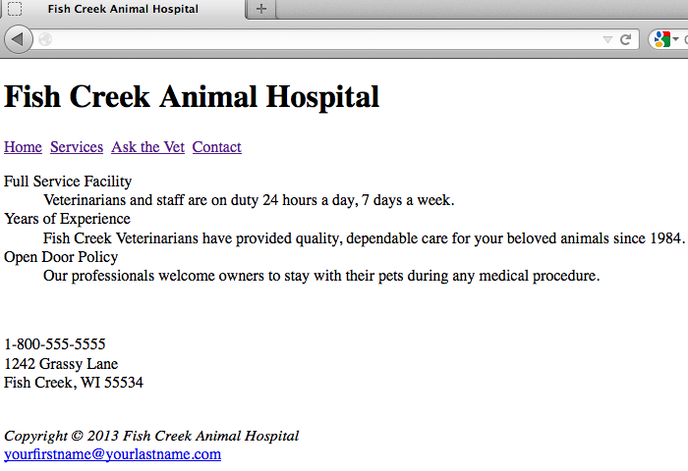

services.html should look like:

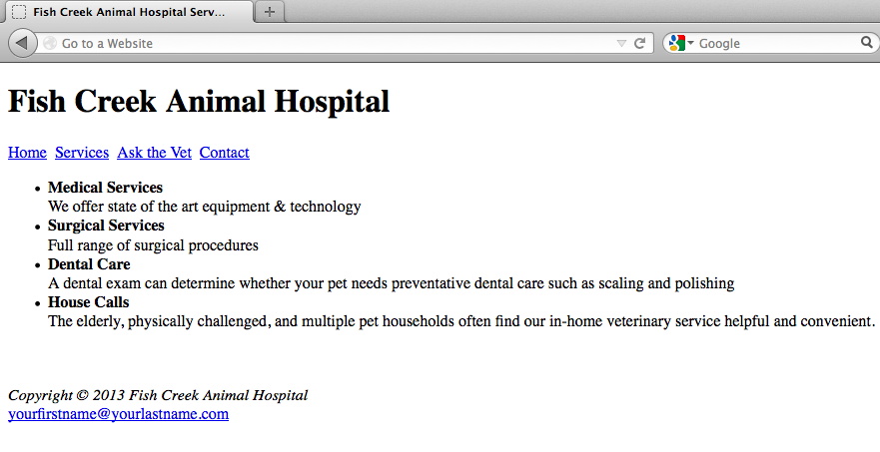

Part II – Using <meta> in an HTML5 page (record in blog)

            - Identify four different uses of the meta tag.
            - Put a meta tag for each of these uses into your Fish Creek Web Pages.
            - Copy the head section/make a screenshot of one of the web pages with the meta tag and paste into your blog.

Part III – Search Engine Optimisation (SEO) (record in blog)

- Read some of the following articles on Search Engine Optimisation (SEO):
http://netm.ag/seostarter-238
https://moz.com/beginners-guide-to-seo
http://searchengineland.com/technical-seo-checklist-7-essential-tips-2017-263936 https://www.singlegrain.com/seo/effective-seo-techniques-that-work/
https://www.searchenginejournal.com/seo-basics-to-be-successful/343811/#close
https://www.lyfemarketing.com/blog/what-is-seo-and-how-it-works/

- Based on reading the aforementioned article(s), or other research/experience, outline four SEO guidelines that you will employ when designing your own websites.

- Write two pieces of code that you will include on your Fish Creek website to improve the SEO of the website.

Part IV – Setting up Github (OPTIONAL)
- Read the following article on Github:
http://readwrite.com/2013/09/30/understanding-github-a-journey-for-beginners-part-1

Watch the following tutorial on Github:
https://www.youtube.com/watch?v=0fKg7e37bQE

- Set yourself up on Github. You should store all of your code files here.

